Learn Arithmetic operations on images

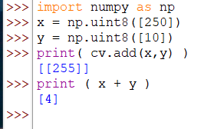

Numpy function is a modulo of 255, opencv is capped at 255

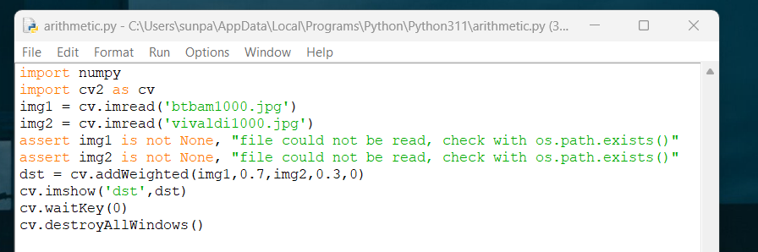

Image blend with addWeighted

Using a 1000 by 1000 picture of vivaldi and btbam

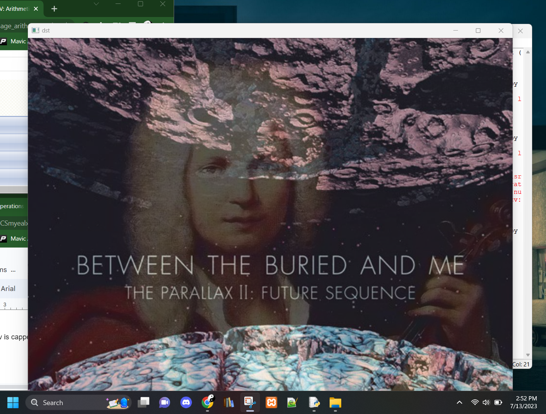

Masking one image over another

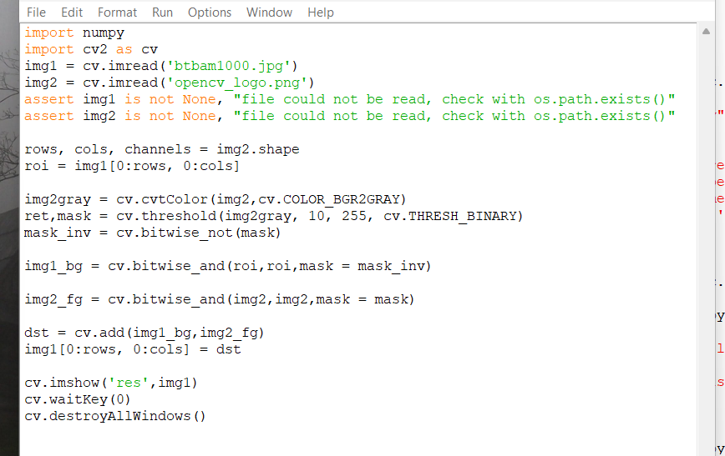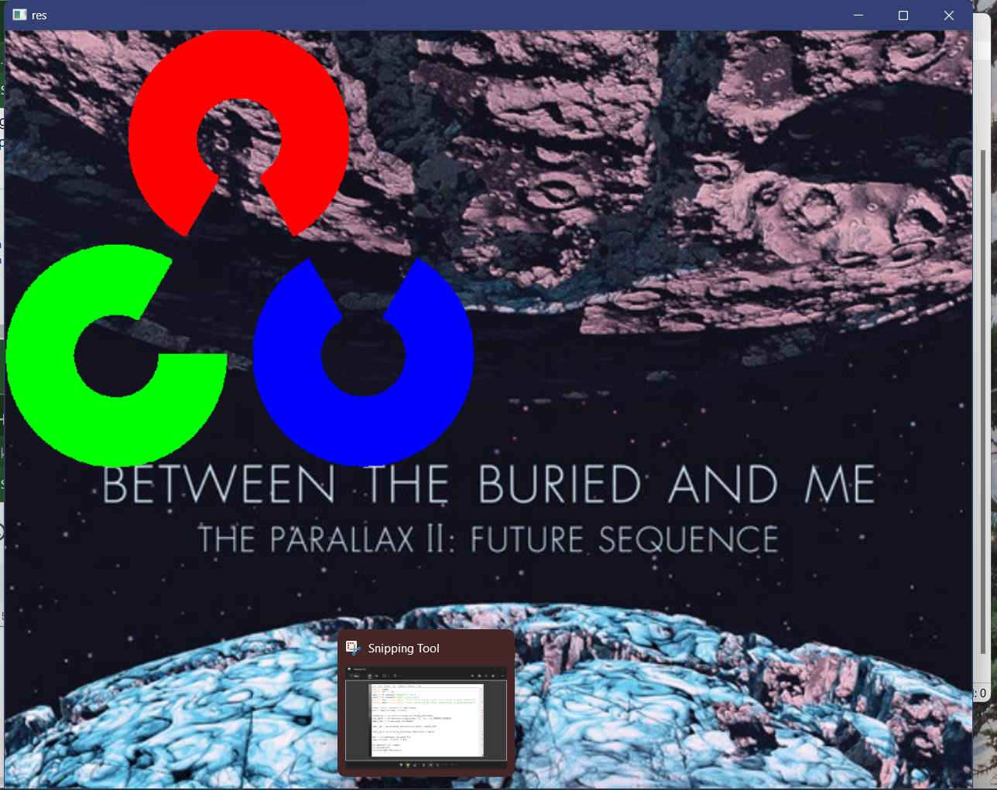

Results

First two images are loaded,

rows , columns and color channels are extracted from img2.shape

Grayscale image of logo is created

Mask is created from threshold function on grayscale image between 10 and 255

Mask is inverted using bitwise not

Mask is blacked out from region of interest (and of inverted mask keeps every pixel where the logo isnt, where the logo is, becomes black)

Take only the region of the logo from the logo image

Foreground logo to background larger image, fits in perfectly